**EXPERIMENT-6**

## **AIM: To make a hole of given diameter on CNC Drilling machine**

**TOOL USED**: - CNC Drilling machine, twist drill (diameter 10.00mm), & Vernier caliper.

**MATERIAL**: - Aluminum plate 100*100*10(mm)

**DIAGRAM &CORDINATES: -**

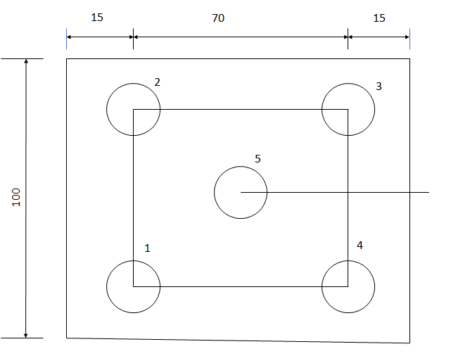

1. 15,15
2. 15,85
3. 85,85
4. 85,15
5. 50,50

**PART PROGRAM**:-

01236;

N001G28 X0 Y0 Z0;

N002 G90 G17 G21;

N003 M06 T01;

N004 M03 S1500;

N005 G00 X15 Y15 Z20;

N006 Z5

N007 G01 Z-10:

N008 G00 Z5;

N009 X15 Y85;

N0010 G01 Z-10;

N0011 G00 Z5;

N0012 X85 Y85;

N0013 G01 Z-10;

N0014 G00 Z5;

N0015 X85 Y15;

N0016 G01 Z-10;

N0017 G00 Z5;

N0018 G00 X50 Y50;

N0019 G01 Z-10;

N0020 G00 Z20;

N0021 G28 X0 Y0 Z0;

N0022 M05;

N0023 M30;

**G00:-**Rapid transverse

**G01:-**Linear interpolation

**PROCEDURE:-**

1. Write the program for the desired job
2. Clamping the job in vice of NC Machine
3. Take offset setting.
4. Simulating the program on C.R.T
5. Editing of the program if required.
6. Simulation of program after editing if needed.

**REMARKS:**

The program is used for cutting desired shape. Depth given by Z. after that tool will return to reference position.